A playful look back at 2025 in Sandwell…
It’s been a big year for children’s play, voices and rights across the borough. Here’s what the Play Service has been up to
Listening to children
In March, Sandwell children and young people joined us at the Council Chambers for a Child Friendly Discovery Day.
They shared their experiences of growing up in the borough and even helped choose the Child Friendly badges and logos. Their voices are shaping a more child-friendly Sandwell. https://www.sandwell.gov.uk/council/child-friendly-sandwell
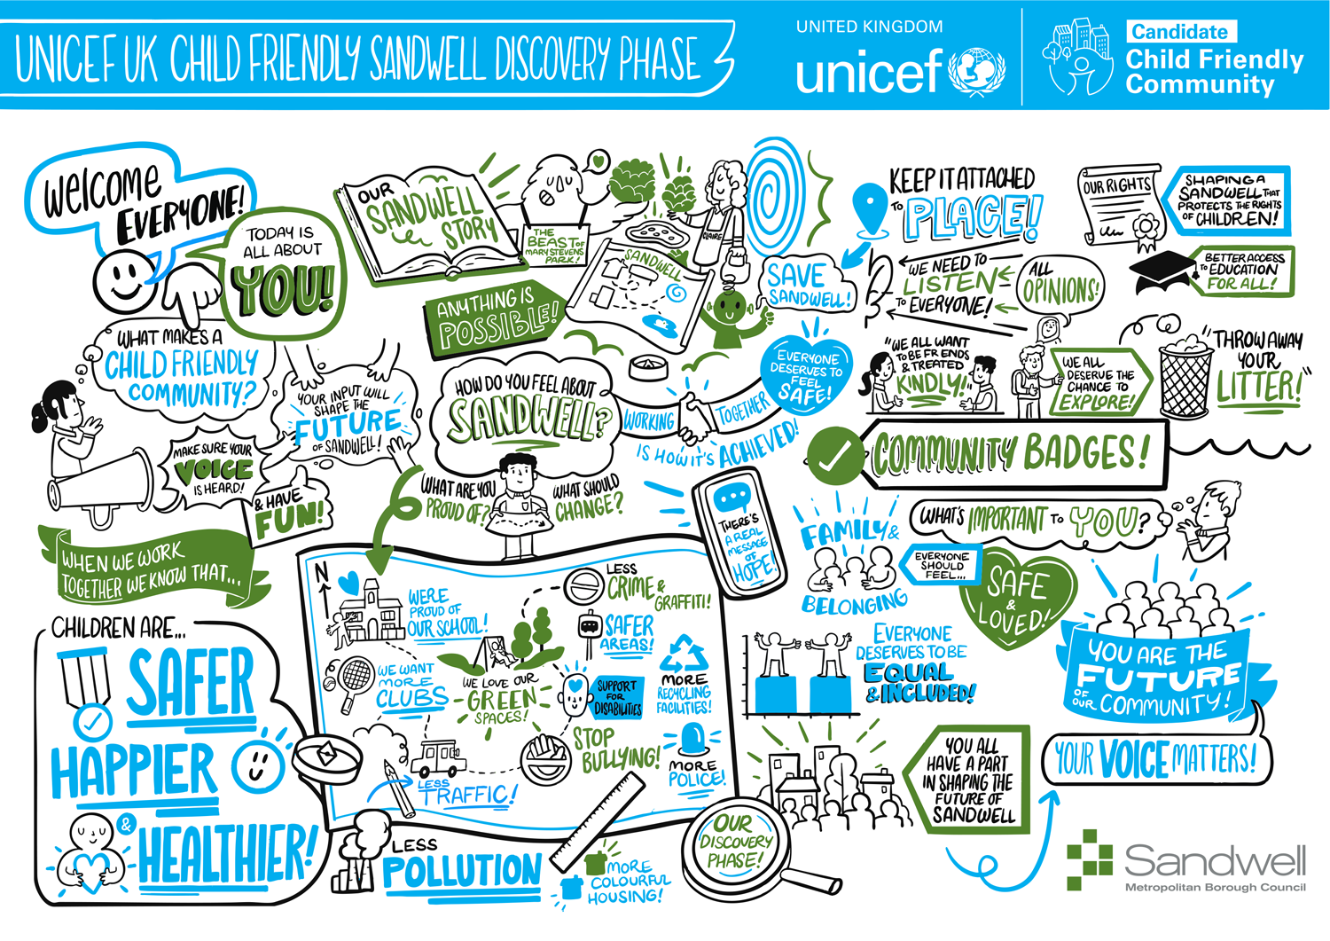
Understanding play
In May, we completed our borough-wide Play Sufficiency research, asking children and young people how they feel about play where they live.
Over 2,000 children and young people took part in our surveys and workshops. The lived experiences they shared have directly shaped our action plan for improving play opportunities across Sandwell. You can read the full report here: www.goplaysandwell.co.uk
In June, we published the findings, helping the council work together to give children more time, space and permission to play.
Bringing play to neighbourhoods
We commissioned 11 grassroots play providers to deliver doorstep play sessions across Sandwell.
That means more weekend and half-term play right where children live


Supporting safer communities
In June, we supported the Safer Six campaign, raising awareness of children’s right to safe, friendly places to play. Because play belongs in every community.
A Summer of Fun
Our Summer of Fun Roadshow travelled across the borough celebrating play:
Lightwoods House – Smethwick, Haden Hill Rowley, Bromwich Hall West Bromwich and Sandwell Valley
National Play Day
We celebrated National Playday at Sandwell Valley on 6 August, welcoming hundreds of children and families to join in the fun. The day was packed with arts and crafts, loose parts play, theatre, and cooking workshops—and the best part? It was completely free!
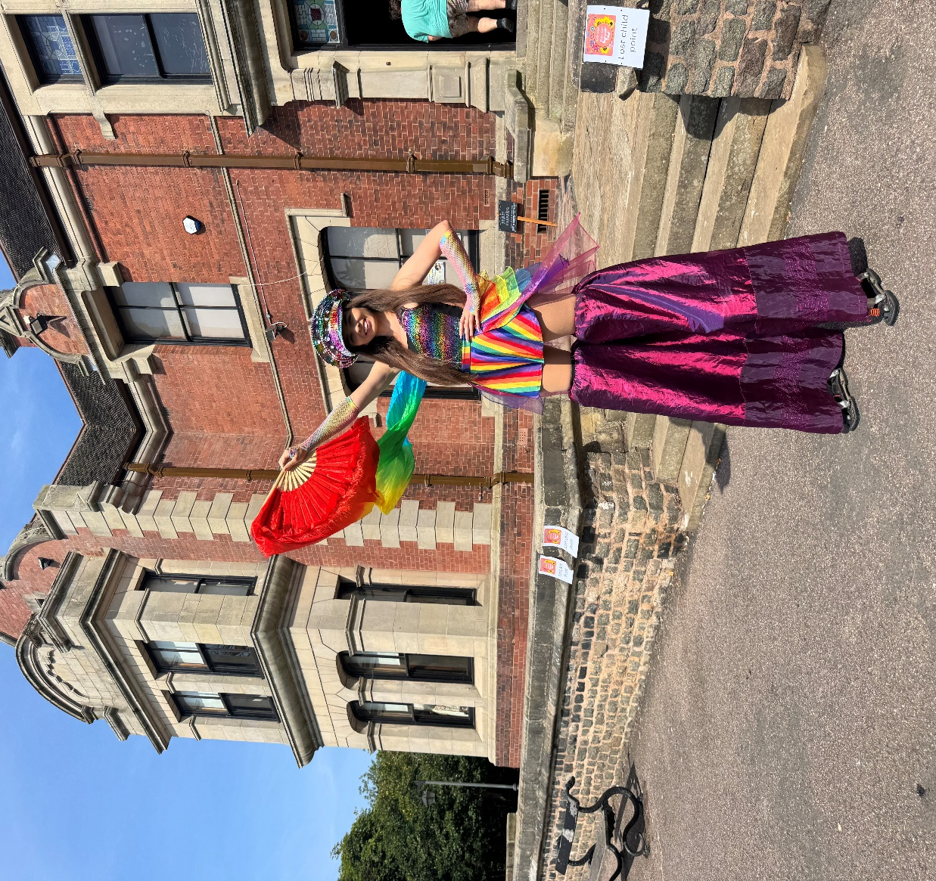

Arts, culture and creativity
Working with Libraries and Museums, we brought six theatre productions (one in each town) to local communities—making arts and culture part of children’s play experiences.
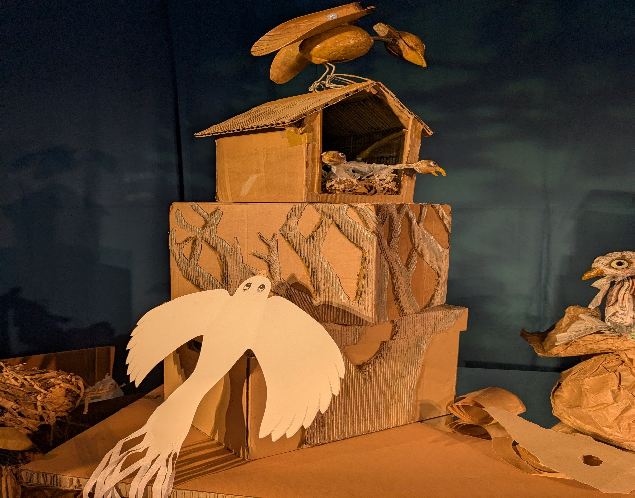
Looking ahead
In December, we recommissioned a 3-year programme of free universal play provision, delivering activities 50 weeks of the year across Sandwell.
We also supported the New Arrivals sessions, creating opportunities for young people to get involved in a welcoming and inclusive environment. These included activities designed for children and young people with SEND.
We also hosted our first-ever Family Raves at Sandwell Valley and Brasshouse Community Centre in Smethwick. The feedback from families was fantastic, and we’re excited to announce that we will be hosting more in 2026!
More play. More opportunities. More happy childhoods.
Thank you to the children, families, schools and partners who made 2025 such a playful year Because when children play, communities thrive.

